Business Performance Report
Data Analytics & Business Intelligence – Task 2
1. KPI Overview
The objective of this analysis was to evaluate business performance using SQL queries, Excel pivot tables, and business intelligence techniques. The analysis was performed using Orders and Customers datasets to generate meaningful business insights.
The following key performance indicators (KPIs) were analysed:
- Total Sales
- Total Profit
- Profit Margin
- Regional Performance
- Category Performance
- Customer Revenue Contribution
- Monthly Sales Trends
SQL JOIN operations were used to combine customer and order information, enabling multidimensional business analysis.
2. Regional Performance Analysis
Regional sales analysis was conducted using SQL aggregation and Excel pivot tables.
Key Findings:
- The West Region generated the highest sales revenue among all regions.
- The East Region also contributed significantly to total sales.
- The South Region recorded comparatively lower sales performance.
- Customer demand and revenue generation varied across regions, indicating different market potentials.
Business Insight:
The organisation should continue strengthening its presence in high-performing regions while implementing targeted marketing strategies to improve sales in underperforming regions.
3. Category Performance Analysis
Product categories were analysed based on sales and profitability.
Key Findings:
- Technology products contributed significantly to revenue generation.
- Furniture products generated substantial sales, but profitability varied due to discounting.
- Office Supplies maintained consistent sales performance across customer segments.
Profit Margin Analysis:
Profit margin calculations revealed that certain categories generated higher profits relative to sales volume. Categories with strong profit margins should receive greater strategic focus for future growth.
Business Insight:
The company should prioritise product categories that deliver both high sales and strong profitability while carefully monitoring discount-driven categories.
4. Customer Analysis
Customer-level analysis was performed using SQL and pivot table techniques.
Key Findings:
- A small group of customers generated a significant share of total revenue.
- Top customers demonstrated higher purchasing frequency and order value.
- Customer segments showed varying contributions to overall sales performance.
Segment Analysis:
- Consumer Segment contributed the largest share of sales.
- Corporate customers generated stable business revenue.
- Home Office customers represented a smaller but valuable customer group.
Business Insight:
Maintaining strong relationships with high-value customers can improve customer retention and long-term revenue growth.
5. Business Recommendations
Based on the analysis, the following recommendations are suggested:
1. Strengthen High-Performing Regions
Focus marketing and sales efforts in regions demonstrating strong revenue potential while exploring opportunities to improve performance in weaker regions.
2. Optimise Product Mix
Increase focus on categories with higher profit margins and consistent customer demand.
3. Improve Customer Retention
Develop loyalty programs and personalised engagement strategies for top-performing customers.
4. Monitor Discount Strategy
Excessive discounts may reduce profitability. Discount policies should be reviewed regularly to maintain healthy profit margins.
5. Use Data-Driven Decision Making
Continue leveraging SQL analysis, dashboard reporting, and KPI monitoring to support strategic business decisions.
6. Conclusion
The analysis successfully demonstrated the use of SQL JOIN operations, KPI calculations, Excel pivot analysis, and business intelligence techniques. The study identified key sales trends, customer behaviours, regional performance differences, and category profitability patterns.
The insights generated from this analysis can help management improve operational efficiency, optimize product strategies, strengthen customer relationships, and support sustainable business growth.

Task 2 SQL Queries Screenshots
Orders Table Row Count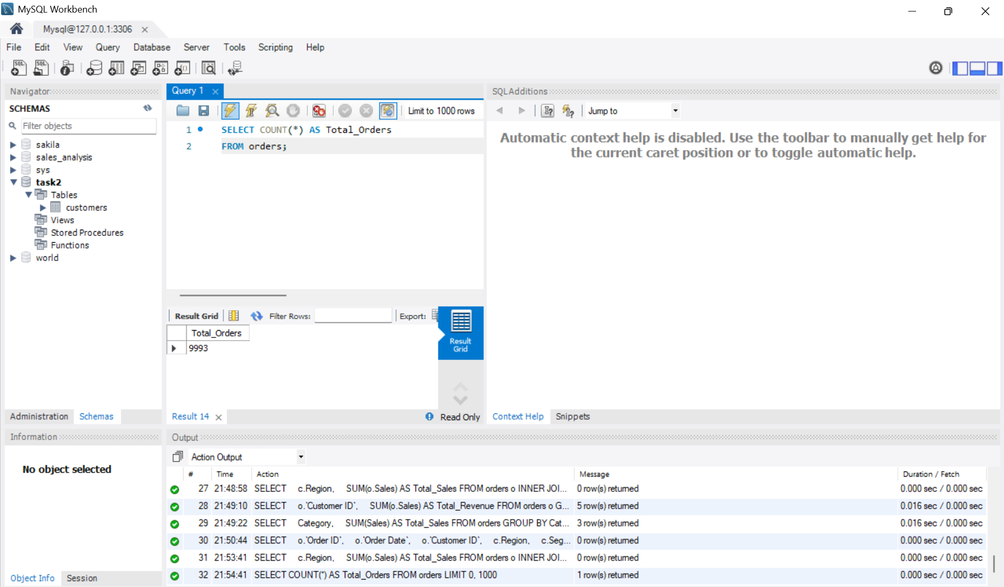

Customers Table Row Count
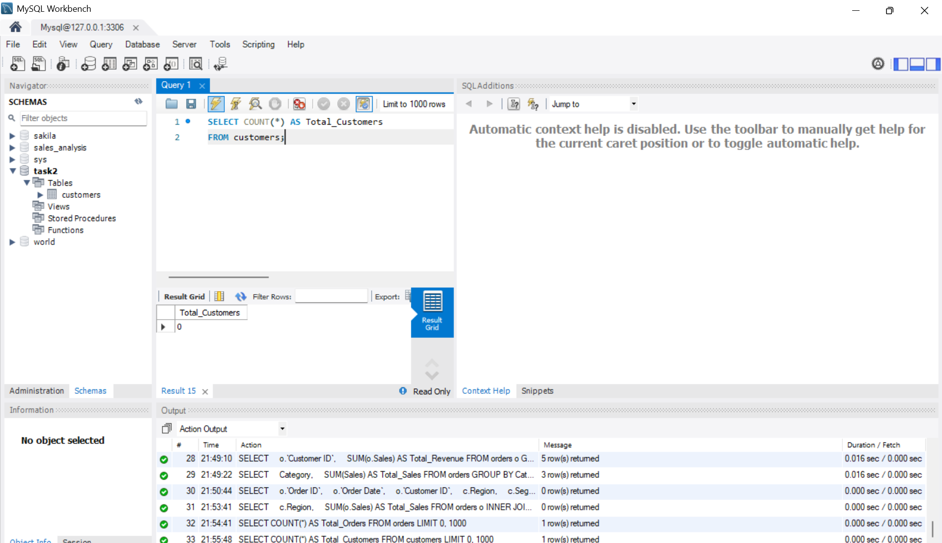

INNER JOIN Output
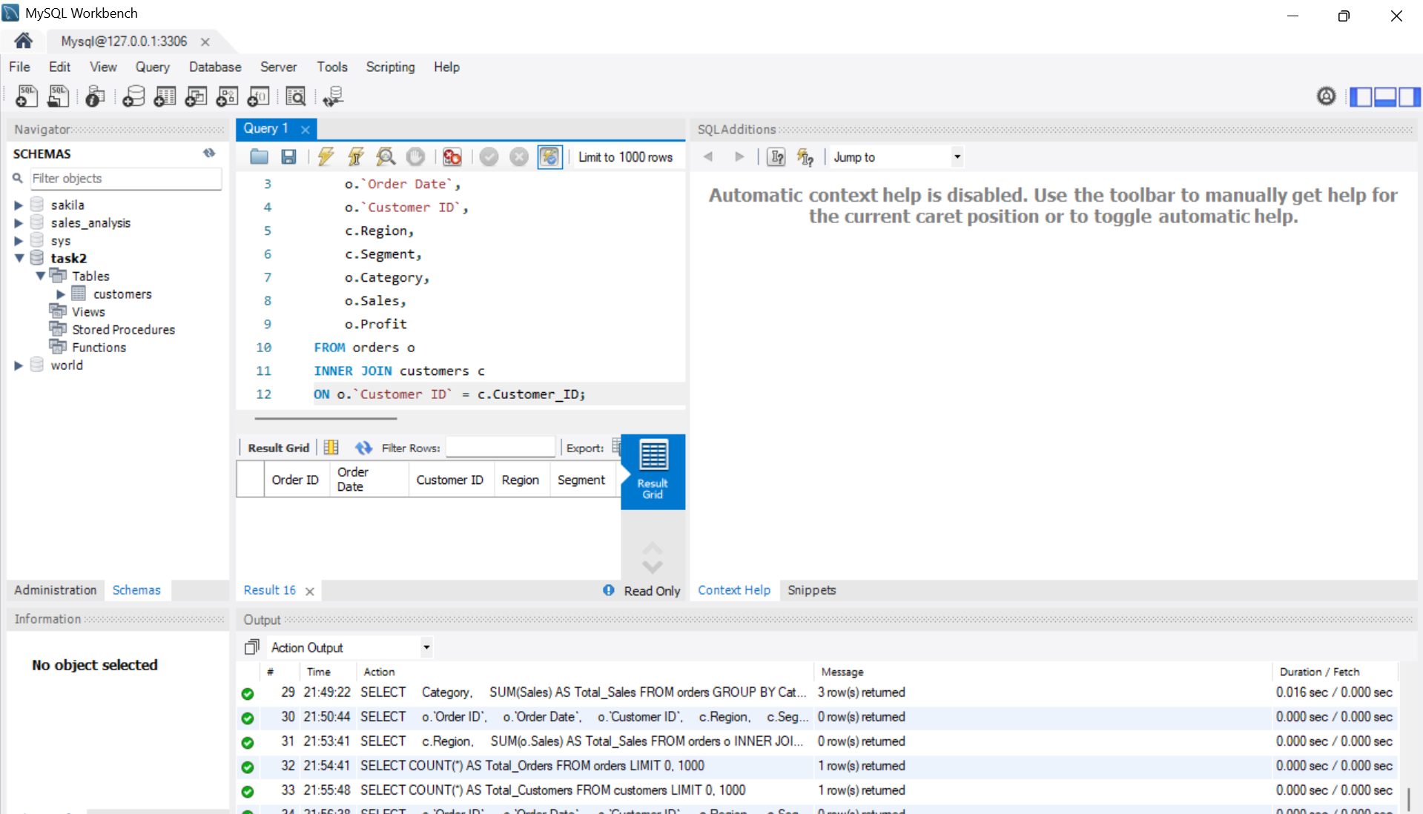

Total Sales by Region
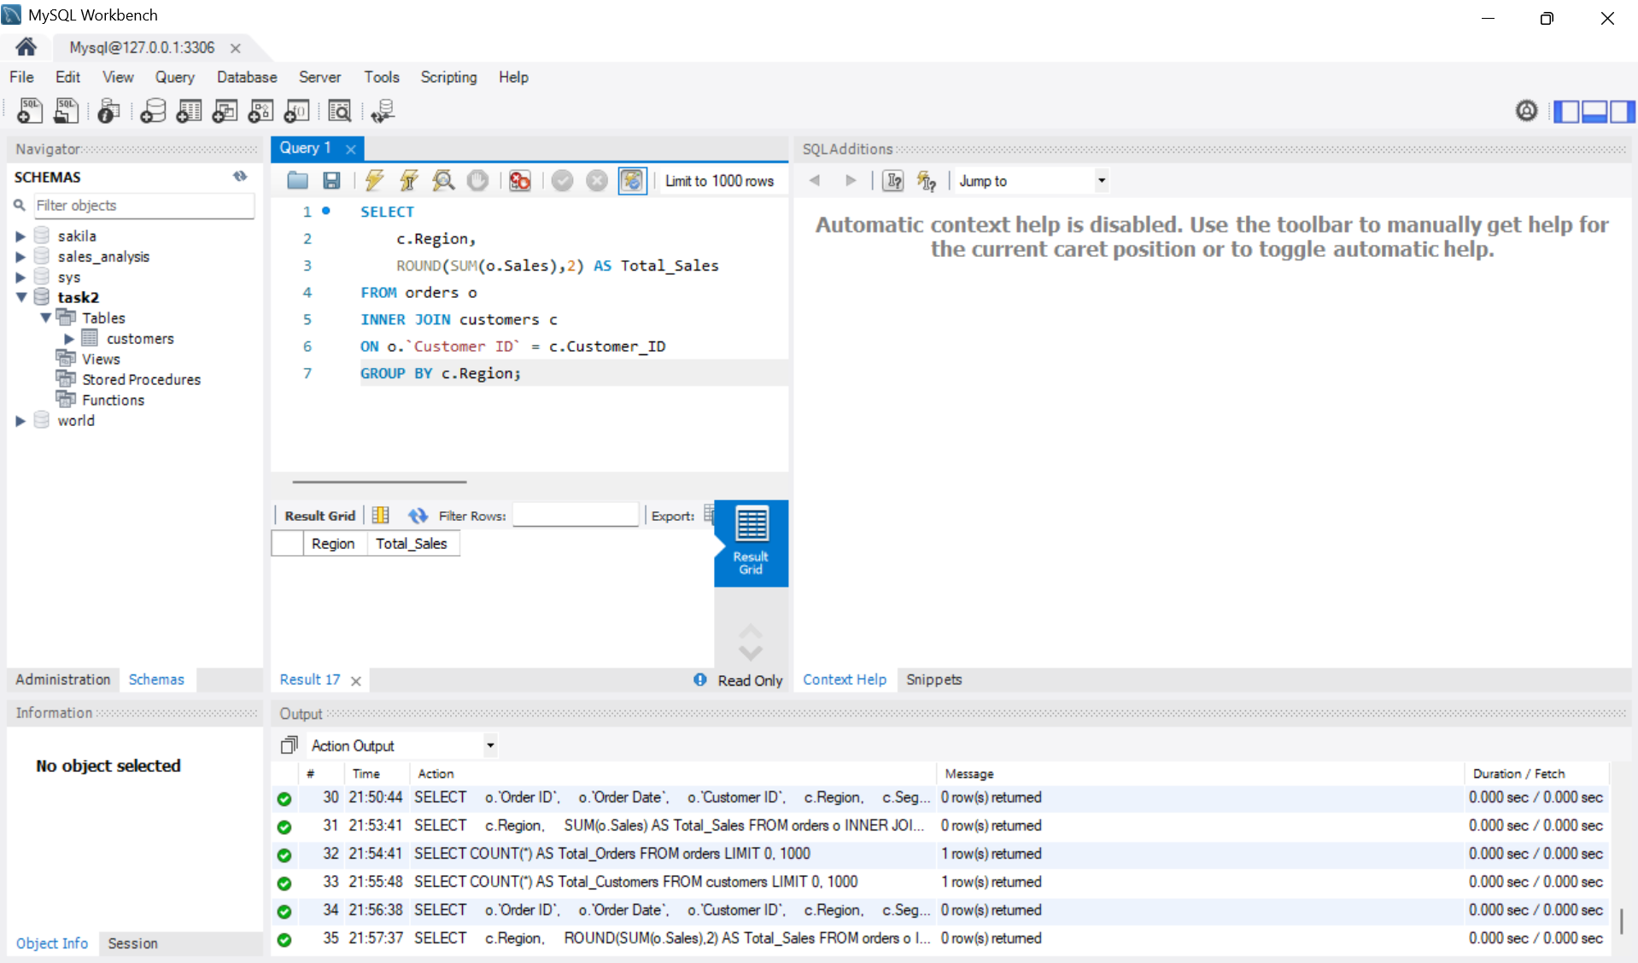

Top 5 Customers by Revenue
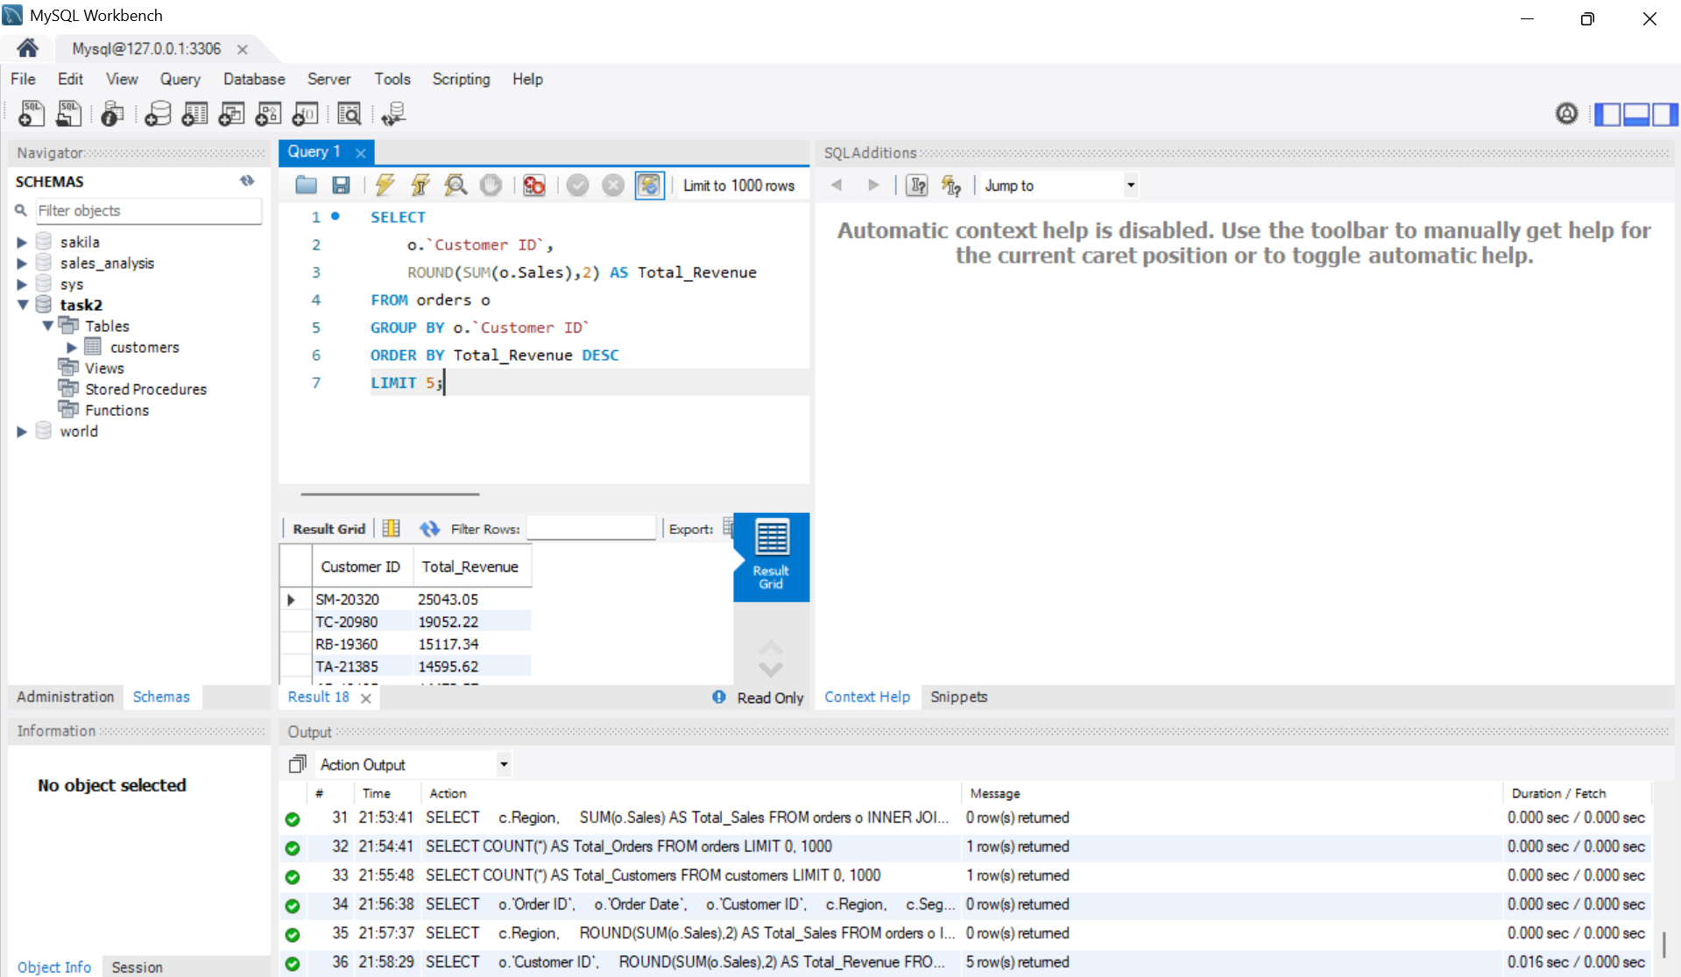

Category-wise Sales
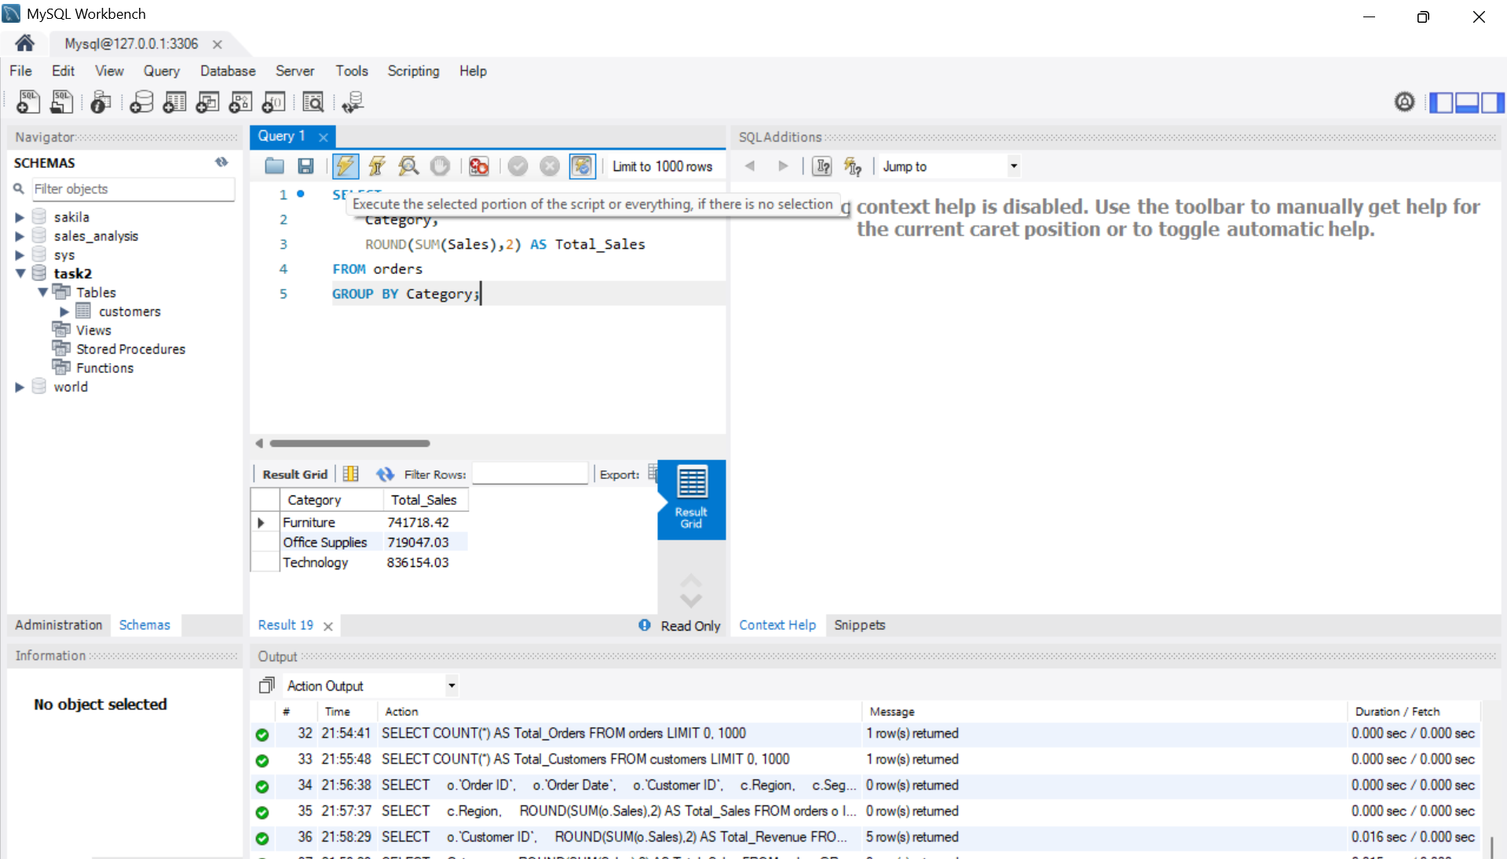

Average Profit by Category
